Webquest Activity Page
Task #1 after viewing number song; please have your child write numbers 1-7 on line below.

Task #2 How many seahorses were in the net before playing the game? Circle the answer

3 5 7 10
Task #3 During the alphabet phonic song which object began with the following picture (circle the correct picture)
A was for: or 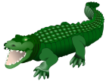 S was for: 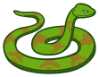 or
C was for: or L was for: 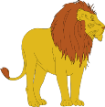 or
M was for: 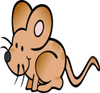 or
Task #4 While you are playing the shape game ask your child what was the shape for the following objects. Have them circle the correct answer.
1.Pizza 2. Drum
Cylinder, circle, rectangle
Triangle, circle, square
3. Sunflower 4. Sailboat
Triangle, oval, rectangle
Circle, cylinder, oval

